Note-: If you are new to AWS, you can create an AWS account and take advantage of the **one-year free tier**. This free tier provides access to a limited set of resources and services at no cost. For more details, you can refer to the official AWS Free Tier page at<https://aws.amazon.com/free>.

1. Deploy Your flask backend and express frontend in amazon single ec2 instance.

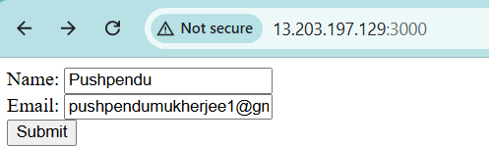

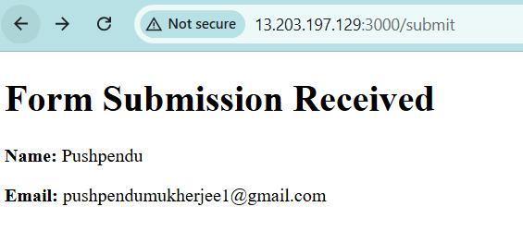

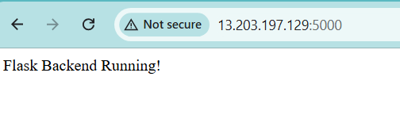

2. Deploy Your flask backend and express frontend in separate ec2 instances.

3. Deploy Your flask backend and express frontend Docker Container using aws ecr, ecs and vpc services

**Submission guidelines** -: Share your github repo link and your deployed app url(first message in the chat before making it live until then stop your instance so that you won’t be cost much)